**1. Course Content**

Sept  **Unit B:** **Chemistry and the Environment** (Ch. 1-2)

(Matter, chemical names and formulas, balancing equations, classifying reactions, acids and bases, acid deposition, titrations; aliphatics, aromatics, organic halides, alcohols, carboxylic acids, esters, polymers) ~ 5 weeks

Oct. **Unit A:** **Maintaining Health** (Ch. 1-2)

(Heart and circulatory system, blood, cardiovascular diseases, immune system; genetics, Punnett squares, inheritance, DNA, mitosis and meiosis, mutations and genetic diseases, pedigree charts, genetic technologies) ~ 4 weeks

Nov.-Dec. **Unit C:** **Electromagnetic Energy** (Ch. 1-2)

(Electric and magnetic fields, motors and generators, series and parallel circuits, resistance, transformers, electromagnetic radiation, astronomy, telescopes, spectral analysis) ~ 4 weeks

Dec. **Unit D:** **Energy and the Environment** (Ch. 1-2)

(Energy consumption, fossil fuels, alternative energies, heat of combustion, calorimetry, nuclear energy; sustainability, geothermal energy, tidal energy, solar energy, hydroelectric power, wind energy, hydrogen fuel) ~ 4 weeks

Jan. Review and Final Exam Preparation

**Thursday, January 28th** **Science 30 P.D.E.**

9:00 – 11:00 AM (Multiple Choice/Numerical Response Only)

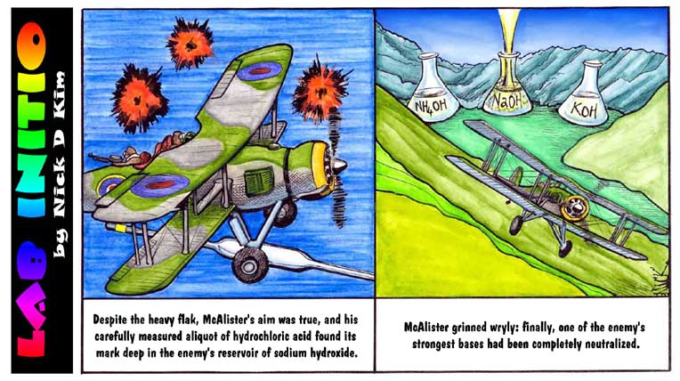

**2. Evaluation**

Assignments, Labs and Quizzes 30%

Tests and Quizzes 40%

Final Exam (P.D.E.) 30%

Total100%

**3. Texts and Materials**

You will need a binder, loose-leaf paper (lined, blank and graph), a ruler and a scientific

calculator (that can do logarithms).

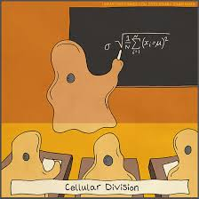

You will be provided with the following:

• Science 30 (Alberta Education)

Additional resources include:

• peer study

• supplementary texts and

audio-visual materials from

the library

• tutoring from the teacher

**4. Aims and Expectations**

This academic course is a pre-requisite for many university, technical institute, and college level courses. Its main goal is to make the student more scientifically aware in a general sense, and more knowledgeable in a specific sense. The four main areas of study represent the areas identified by Alberta Education as being the most important to understanding a wide variety of chemical, physical and biological phenomena. Specific course objectives are available upon request.

In order to succeed, students will put forth a reasonable amount of time and effort to complete all homework, reading assignments and lab reports. **This course has a moderate workload.** Suggested time to put aside is 15 – 30 minutes per night. Any work not completed in class is considered homework. Regular and consistent **attendance** and **effort** are the keys to doing well in this course.

**Missed work is the responsibility of the student. Missed assignments may greatly affect student marks.** Missed tests will be written on your first day back unless you have a very good reason. Inexcusable absences on a test day will result in a zero. I usually give the class considerable freedom and input on the date of tests in order to accommodate other subject area tests, major assignments, etc.

