Goals:
- To develop and promote skills and attitudes associated with mathematical literacy
- To learn the prescribed curriculum as a prerequisite for future courses in mathematics.
- To prepare students for the expectations of the high school 10/20/30 curriculum.
Course Evaluation
- Assessment in this course will be broken down into outcomes, similar to the assessment practices your student experienced in middle school.
- Students will receive an overall percentage grade on each assessment, and will also receive more detailed feedback on each outcome within the assessment (Mastery, Advancing, Progressing, Emerging, Beginning, Limited, or Not Meeting). This will allow students and parents to see the student’s level of understanding on each outcome, in order to identify areas of growth to focus on for subsequent assessments.
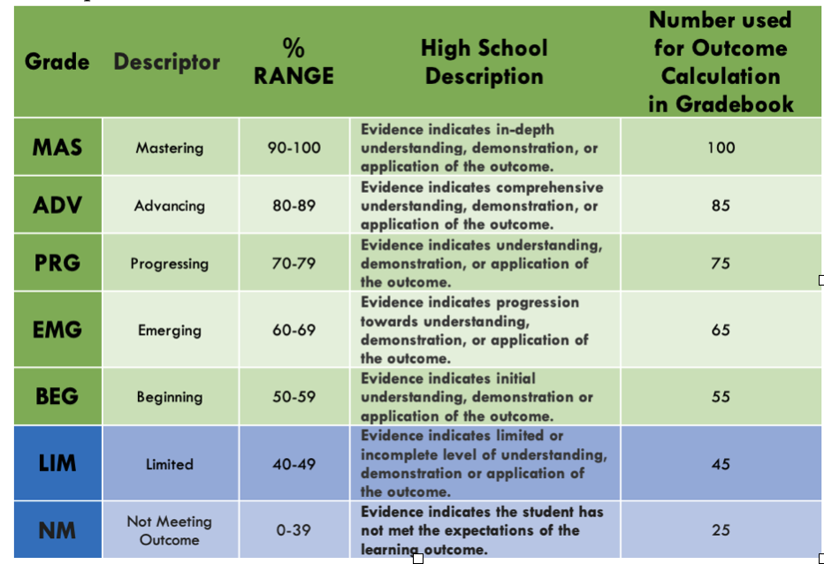

- It is the proficiency level on each outcome (MAS, ADV, etc.), rather than the overall assessment score that contributes to the course grade percentage.
- Each outcome will be assessed summatively at least twice, once during the unit, and once on the cumulative assessment. The cumulative assessments will take place after each unit. There will also be a third opportunity available if needed.
- In addition to the summative assessments, more frequent formative feedback will be given throughout the unit to identify areas of strength and offer opportunity to improve on areas for growth.
Unit | Topics | % of Final Report
Number Sense | Powers  Exponent Law of Powers  Rational Numbers and Square Roots | 27%
Patterns & Relations | Linear Relations  Linear Inequalities  Polynomials | 32%
Shape & Space | Circles and Composite 3-D Objects  Scaling, Similar Triangles, and Polygons  Rotation Symmetry and Transformations | 23%
Statistics & Probability | Data Analysis | 18%
Total |  | 100%

Overall Math 9 Course Grades:
Math 9: Full Year Course 90 %
PAT: 10 %
100%

Required Materials
- Alberta Education requires that technology be used in order to achieve learner outcomes. All Mathematics 9 students must have at minimum a scientific calculator available to use in the classroom.
- Students will require a scientific calculator. Graphing calculators are not permitted.
- In addition to a calculator, students will also require pencils, an eraser, graph paper, and a geometry set.
- All math work must be done in pencil. Work in pen will not be accepted.
- Students will need to bring their laptops daily

Power School:
- Be sure to check power school frequently for updated marks.
Google Classroom:

All students are required to join the Google Classroom for Math 9 using the following class code.
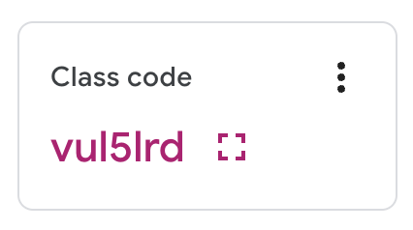

Teacher Introduction:
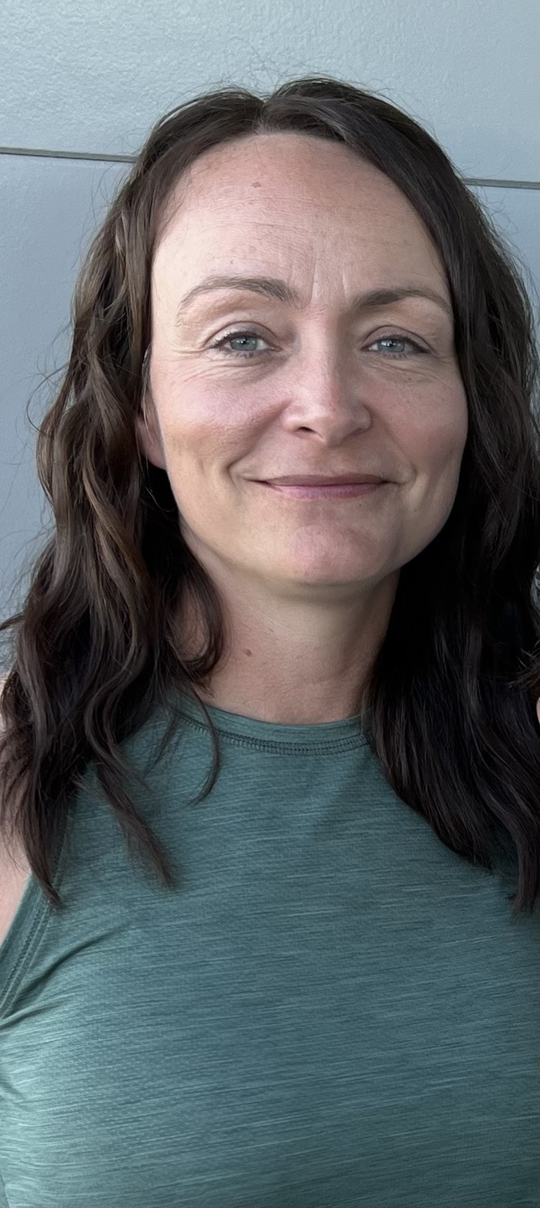
Hello,

My name is Tammy Hawco and I have been teaching math for 20 years. This is my second year teaching at Bow Valley High School. I will be teaching Grade 9 Math, Grade 9 Science, Grade 10 Math, Grade 10 Science, and Science 24.

The best way to reach me is via email at thawco@rockyview.ab.ca as I check this email daily. Teachers do have a Gmail account, however, this account receives an abundance of notifications from Google and rarely receives focused emails. Thus, I rarely check my Gmail account.

I am excited to get to know this year's group of students and to also see some returning faces from last year! Please feel free to reach out to me with any concerns you have. When teachers, students and parents work together goals are more attainable and everyone wins!

