Science 10 Course Outline 2023-24

Instructor: Ms. Tammy Hawco
BOW VALLEY HIGH SCHOOL

Email: thawco@rockyview.ab.ca
The best way to contact me is through email. I check my email often and will respond within 24 hours on school days.

Prerequisite:
Science 9, 14 or 24

Resources:
Textbook: Science Focus 10 (online version on the Google Classroom)
Course Documents: Google Classroom
Workbook (Schoolcash $20) – We will use this frequently.

Overview:

The objective of Science 10 is to build upon the foundations that have been established in previous science courses by fostering an interest in science and an appreciation for its value and applications in our society. Students will develop skills in scientific discovery, investigation, and inquiry. This course will prepare students for continued growth and learning in the sciences in high school and beyond.
Course Outcome Breakdown:

Unit | Outcomes
Unit A:  Energy and Matter in Chemical Change  25% | A1. Atomic Structure- Describe the basic particles that make up the underlying structure of matter, and investigate related technologies  A2. Compounds- Explain, using the periodic table, how elements combine to form compounds, and follow IUPAC guidelines for naming ionic compounds and simple molecular compounds  A3. Chemical Reactions- Identify and classify chemical changes, and write word and balanced chemical equations for significant chemical reactions, as applications of Lavoisier’s law of conservation of mass
Unit B:  Energy Flow in Technological Systems  20% | B1. Thermodynamics- Analyze and illustrate how technologies based on thermodynamic principles were developed before the laws of thermodynamics were formulated  B2. Mechanical Systems- Explain and apply concepts used in theoretical and practical measures of energy in mechanical systems  B3. Efficiency - Apply the principles of energy conservation and thermodynamics to investigate, describe and predict efficiency of energy transformation in technological systems
Unit C:  Cycling of Matter in Living Systems  20% | C1. Imaging- Explain the relationship between developments in imaging technology and the current understanding of the cell  C2. Cell Organelles- Describe the function of cell organelles and structures in a cell, and use models to explain these processes and their applications  C3. Cell Specialization- Analyze plants as an example of a multicellular organism with specialized structures at the cellular, tissue and system levels
Unit D:  Energy Flow in Global Systems  15% | D1. Biosphere- Describe how the relationships among input solar energy, output terrestrial energy and energy flow within the biosphere affect the lives of humans and other species  D2. Energy Transfers- Analyze the relationships among net solar energy, global energy transfer processes—radiation, convection and hydrologic cycle—climate  D3. Climate and Biomes- Relate climate to the characteristics of the world’s major biomes, and compare biomes in different regions of the world  D4. Climate Change - Investigate and interpret the role of environmental factors on global energy transfer and climate change
Scientific  Skills  20% | SK1. Initiate & Plan- Ask questions about observed relationships, and plan investigations of questions, ideas, problems and issues  SK2. Perform & Record- Conduct investigations into relationships between and among observed variables and use a broad range of tools and techniques to gather and record data and information.  SK3. Analyze & Interpret- Analyze data and apply mathematical and conceptual models to develop and assess possible solutions.SK4. Communication & Teamwork- Work as members of a team in addressing problems, and apply the skills and conventions of science in communicating information and ideas and in assessing results

Course Evaluation:

- Assessment in this course will be broken down into outcomes, similar to the assessment practices your student experienced in grade 9.

- For example, the Energy and Matter in Chemical Change unit assessment will consist of 3 outcomes:
  - Describe the basic particles that make up matter
  - Explain using the periodic table, how elements combine to form compounds
  - Identify and classify chemical changes and write work and balanced chemical equations

- Students will receive an overall percentage grade on each assessment and will also receive more detailed feedback on each outcome within the assessment (Mastery, Advancing, Progressing, Emerging, Beginning, Limited, or Not Meeting). This will allow students and parents to see the student’s level of understanding on each outcome, in order to identify areas of growth to focus on for subsequent assessments.

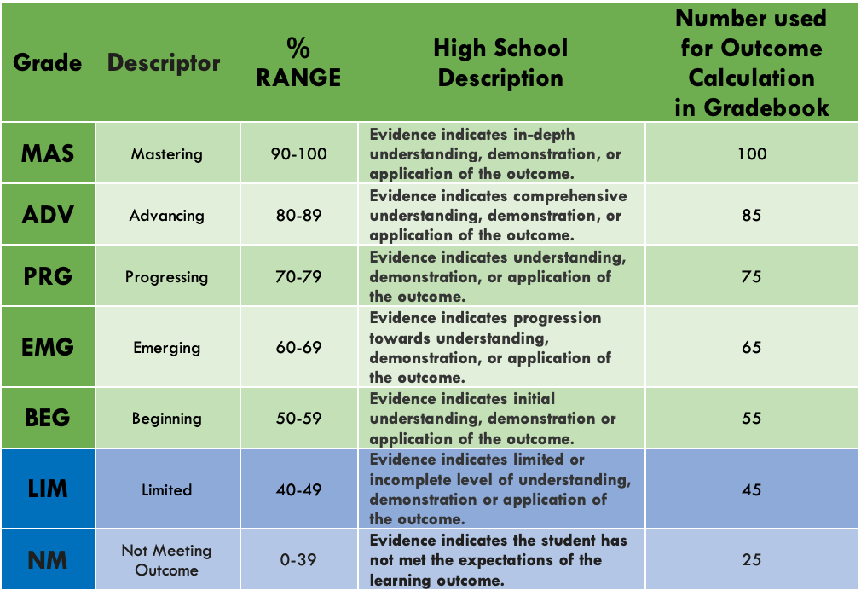
- It is the proficiency level on each outcome (MAS, ADV, etc.), rather than the overall assessment score that contributes to the course grade percentage.

Assessment Policy:

Each outcome will be assessed summatively at least twice.
Re-assessment will be built into the course, there will also be three reassessment periods throughout the semester.
Professional judgement will be used to determine a student’s overall outcome grade (i.e., more recent evidence may replace previous evidence, so that students can show growth, and not necessarily be penalized for previous misconceptions).

Students will have the opportunity to review all assessments in the classroom. Feedback and learning from mistakes are essential to the learning process. It is imperative that students use this opportunity to enhance their comprehension of the outcomes. Time will be allotted during class for this process, and students may also request to review assessments within the classroom at another time. If students are unsure of what resources are available or next steps to take to improve their understanding, they should discuss this with the classroom teacher.

In order to maintain security of assessments:
- students will not be permitted to leave the classroom while writing an assessment
- phones must be put away during assessments and when reviewing assessments
- assessments will not be permitted to leave the classroom, and taking photos of assessments is prohibited

If a student is absent on the day of an assessment, they will be required to write the assessment their first day back to school provided the assessment has not yet been returned to students. If the assessment has been returned, the student will complete the assessment during the next reassessment opportunity.

Assessment grades will be entered into PowerSchool within 3 days of it being written.
Assessments will be returned for students to review within 1 week of it being written and at least 2 days in advance of the next assessment.

Summative Assessments = 100%
- Each outcome will be assessed summatively at least twice, once during the unit (projects, quizzes, labs, review assignments, etc.) and once on the unit assessment. The unit assessments will take place after each unit.

*Note that summative assessments are not all weighted equally, some summative assessments (i.e., Tests) will be weighted more heavily than other summative assessments.
Formative Assessments = 0%
- In addition to the summative assessments, more frequent formative feedback will be given throughout the unit (assignments, check-ins, etc.) to identify areas of strength and offer opportunity to improve on areas for growth.

*Formative Assessments are vital to enhancing skills used during summative work.

Technology Expectations:
- Regular access to a computer
- Good internet connection
- Ability to send and receive email attachments
- Google Classroom

Technical Support:
- studentsupport@rockyview.ab.ca
- Phone: 403.945.4083.

Final Due Dates:

ALL due dates for assignments will be listed on the Google Classroom. You will have another opportunity to submit work before the extended deadline (which will be the date of the unit exam) with a 10% deduction for lateness. After that, you must communicate with the teacher if you wish to complete missing work from previous units. The final due date to submit any course work will be 4pm on the last day of classes in the semester which you are completing the course.

Student Responsibility:

Respect | - Please respect the learning environment by:  - Treating others as you would like to be treated.  - Respecting the learning environment.  - Participating by “the person speaking is the most important person” motto.  - Do not order Skip the Dishes/Door Dash during class.
Resources | - Text: Science Focus 10 (online version on the Google Classroom)  - Workbook: Science 10 Workbook is available on SchoolCash for $20  - Science 10-Google Classroom:  - Students will be required to access and retrieve documents from Google Classroom.  - Google Classroom will contain resources including:  notes packages / PowerPoints, assignments, assessments, review packages and other general documents.  - Students are also responsible for checking Google Classroom for class and school announcements.
Expectations | - Attend all classes and be on time.  - Complete all assignments & meet deadlines.  - Ask questions if you do not understand.
Attendance | - Attendance is taken each class.  - Frequent tardiness and absenteeism will be dealt with by the teacher.
Personal Supplies | - Students will need the following personal supplies:  - Computer with Internet access  - Stationary Supplies  (Pens, pencils, eraser, highlighter, tape, scissors etc.)  - Calculator  - Highly Recommended: binder (1 inch) with lined and graph paper
Dates & Deadlines | - Assessment dates and times will be posted on Google Classroom and the classroom whiteboard.  - Late or Missed assignments /assessments will be dealt with by the teacher.
Cell Phones | - Cell phones cannot be used for any summative assessments.
Missed Classes | - Please see the teacher regarding absences from class.  - It is your responsibility to study missed content and make up missed work.
Help | - Questions can be asked through email or in person.  - Questions will be attended to during school hours.

Academic Honesty is a reflective practice; whereby students connect their understanding of academically honest practices into the demonstration of those practices in their work.

Students must read, understand and act in accordance with the Academic Honesty Policy of Bow Valley High School, which is embedded in the course outline.
It is the student’s responsibility to ensure that all work submitted is authentic in all respects. Work submitted is inclusive of written, oral, creative or other forms of assessment for a course.

A student must be aware of and purposefully ensure that they are demonstrating appropriate academic behaviours as it relates to:
Plagiarism | This is defined as the representation of the ideas or work of  another person as the [student’s] own
Collusion | This is defined as supporting malpractice by allowing another student to submit work completed by you; or submitting another  [student’s] work as your own.
Misconduct | This is defined as the use of unauthorized communication of any form during an assessment.
Duplication of  Work | This is defined as the presentation of the same work for different assessment components.
Inappropriate Communication of Information | This is defined as the communication of assessment information to [students] who have yet to complete a similar assessment; or requesting others [students] to divulge information about an  upcoming assessment that may provide the [student] with an unfair advantage.

Students are expected to value the attitudes and skills of being a principled communicator in all learning and assessment. Consequences for those who compromise the academic honesty and integrity policy to gain an advantage are listed below.

- A zero will be awarded for that assignment/exam.

It is my hope that you find this course educational and enjoyable!

Google Classroom: Please join the Google Classroom for this course using the following code.
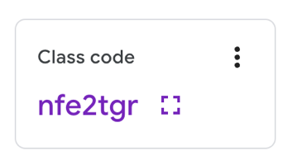

Teacher Introduction:
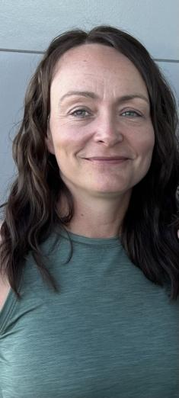
Hello,

My name is Tammy Hawco and I have been teaching math for 20 years. This is my second year teaching at Bow Valley High School. I will be teaching Grade 9 Math, Grade 9 Science, Grade 10 Math, Grade 10 Science, and Science 24.
The best way to reach me is via email at thawco@rockyview.ab.ca as I check this email daily. Teachers do have a Gmail account, however, this account receives an abundance of notifications from Google and rarely receives focused emails. Thus, I rarely check my Gmail account.
I am excited to get to know this year's group of students and to also see some returning faces from last year! Please feel free to reach out to me with any concerns you have. When teachers, students and parents work together goals are more attainable and everyone wins!

