Instructor: Tammy Hawco
BOW VALLEY HIGH SCHOOL
Email: thawco@rockyview.ab.ca

The best way to contact me is through email. I check my email often and will respond within 24 hours on school days. Please use the email address above as I do not check Gmail regularly.

Overview
The objective of Science 9 is to build upon the foundations that have been established in previous science courses by fostering an interest in science and an appreciation for its value and applications in our society. Students will develop skills in scientific discovery, investigation, and inquiry. This course will prepare students for continued growth and learning in the sciences in high school and beyond.
Course Outcome Breakdown

Unit | Outcomes | % of Final Report
Biological Diversity | 4
Matter & Chemical Change | 4
Environmental Chemistry | 3
Electrical Principles & Technologies | 4
Space Exploration | 4
Skills and Labs | 4
Total  (Course-awarded grade) | 23  (each outcome is weighted equally) | 90%
Provincial Achievement Test (PAT) |  | 10%

Course Evaluation
- Assessment in this course will be broken down into outcomes, similar to the assessment practices your student experienced in middle school.
- For example, the Biodiversity unit assessment will consist of 4 outcomes:
  - Describe how diversity contributes to species survival
  - Investigate the role of reproductive processes in transmitting characteristics
  - Describe the role of genetic materials in the variation of species
  - Identify impacts of human action on species survival
- Students will receive an overall percentage grade on each assessment and will also receive more detailed feedback on each outcome within the assessment (Mastery, Advancing, Progressing, Emerging, Beginning, Limited, or Not Meeting). This will allow students and parents to see the student’s level of understanding on each outcome, in order to identify areas of growth to focus on for subsequent assessments.
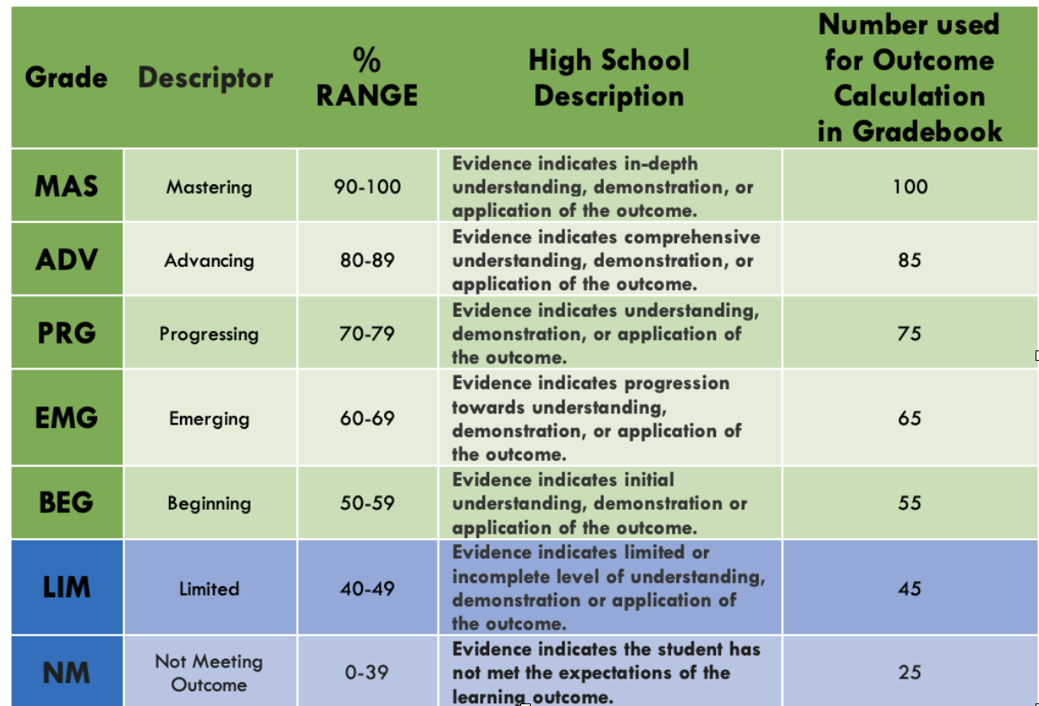
- It is the proficiency level on each outcome (MAS, ADV, etc.), rather than the overall assessment score that contributes to the course grade percentage.

Assessment Policy

Each outcome will be assessed summatively at least twice.
Re-assessment will be built into the course, there will also be three reassessment periods throughout the semester.

Professional judgement will be used to determine a student’s overall outcome grade (i.e., more recent evidence may replace previous evidence, so that students can show growth, and not necessarily be penalized for previous misconceptions).

Students will have the opportunity to review all assessments in the classroom. Feedback and learning from mistakes are essential to the learning process. It is imperative that students use this opportunity to enhance their comprehension of the outcomes. Time will be allotted during class for this process, and students may also request to review assessments within the classroom at another time. If students are unsure of what resources are available or next steps to take to improve their understanding, they should discuss this with the classroom teacher.

In order to maintain security of assessments:
- students will not be permitted to leave the classroom while writing an assessment
- phones must be put away during assessments and when reviewing assessments
- assessments will not be permitted to leave the classroom, and taking photos of assessments is prohibited

If a student is absent on the day of an assessment, they will be required to write the assessment their first day back to school provided the assessment has not yet been returned to students. If the assessment has been returned, the student will complete the assessment during the next reassessment opportunity.

Assessment grades will be entered into PowerSchool within 3 days of it being written.
Assessments will be returned for students to review within 1 week of it being written and at least 2 days in advance of the next assessment.

Google Classroom: Please join the course using this following code.
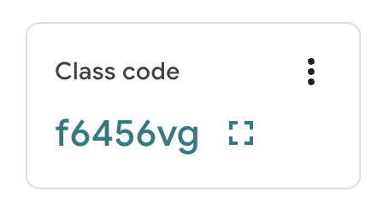
Teacher Introduction:

Hello,
My name is Tammy Hawco and I have been teaching math for 20 years. This is my second year teaching at Bow Valley High School. I will be teaching Grade 9 Math, Grade 9 Science, Grade 10 Math, Grade 10 Science, and Science 24.

The best way to reach me is via email at thawco@rockyview.ab.ca as I check this email daily. Teachers do have a Gmail account, however, this account receives an abundance of notifications from Google and rarely receives focused emails. Thus, I rarely check my Gmail account.

I am excited to get to know this year's group of students and to also see some returning faces from last year! Please feel free to reach out to me with any concerns you have. When teachers, students and parents work together goals are more attainable and everyone wins!

