Meeting Minutes
Bow Valley High School Council
October 13, 2022, 7 PM
Learning Commons
1. Call to order - call to order at 7:03
2. Welcome and Introductions : Shelly Horb, Karen Johnston, Melissa Evans, Tracy Bruins, Julie Stall, Taylor Grant, Joan Waringer, Sara Webster, Tina Pearson, Nicola Wright, Alicia Graham, Anne Hayter, Kim Barden, Brett & Erin Reiben, Erin Drysdale, Jim Frid, Mike Evans, Sheri Tarrington, Rhonda Gervais, Claire Stone, Tracy Brooker,Kari Rose, Shane Dempster
Student Presentation by Bella- School Thrift Store
- Student led project
- 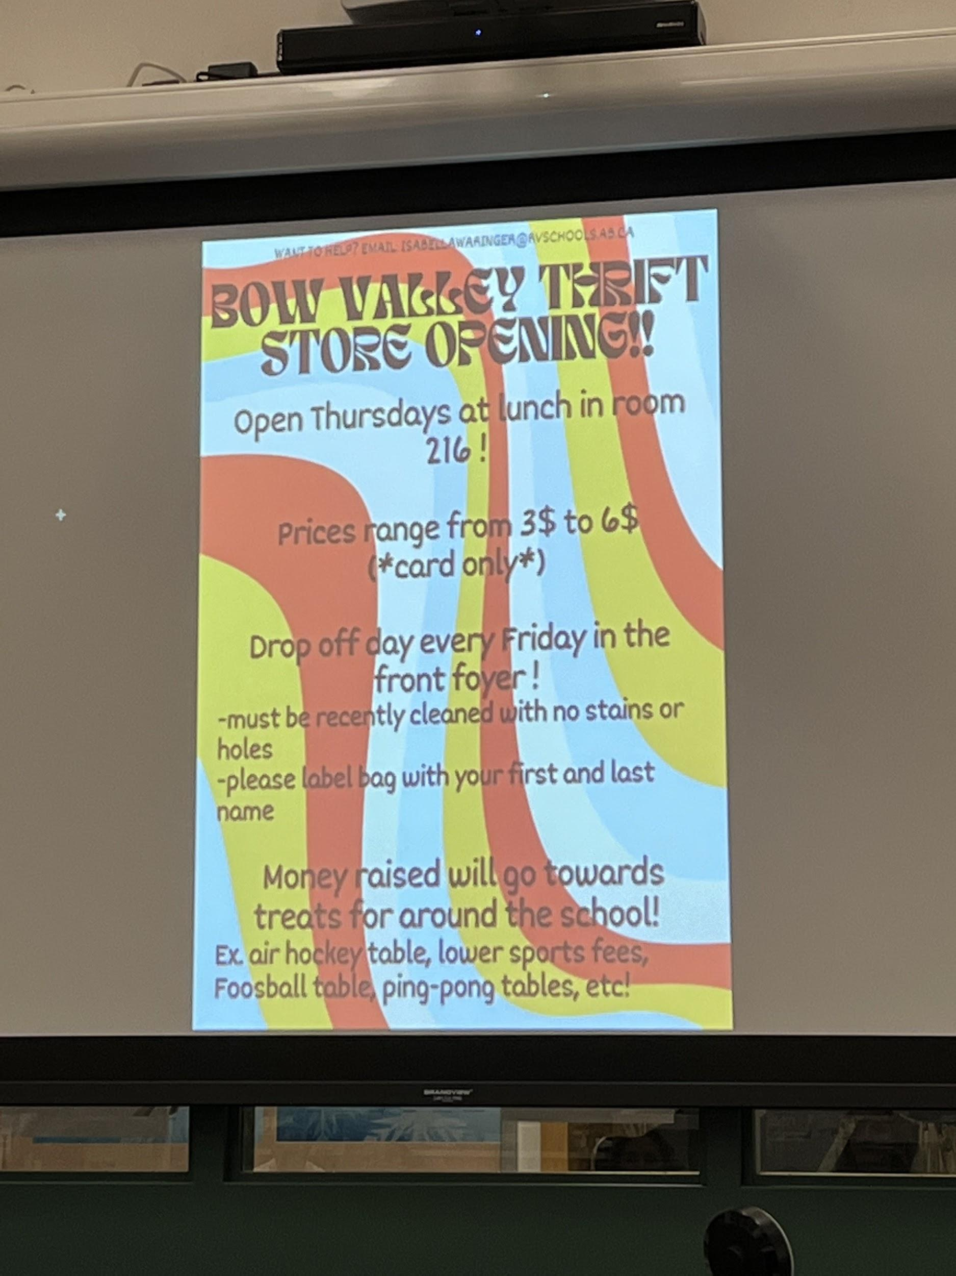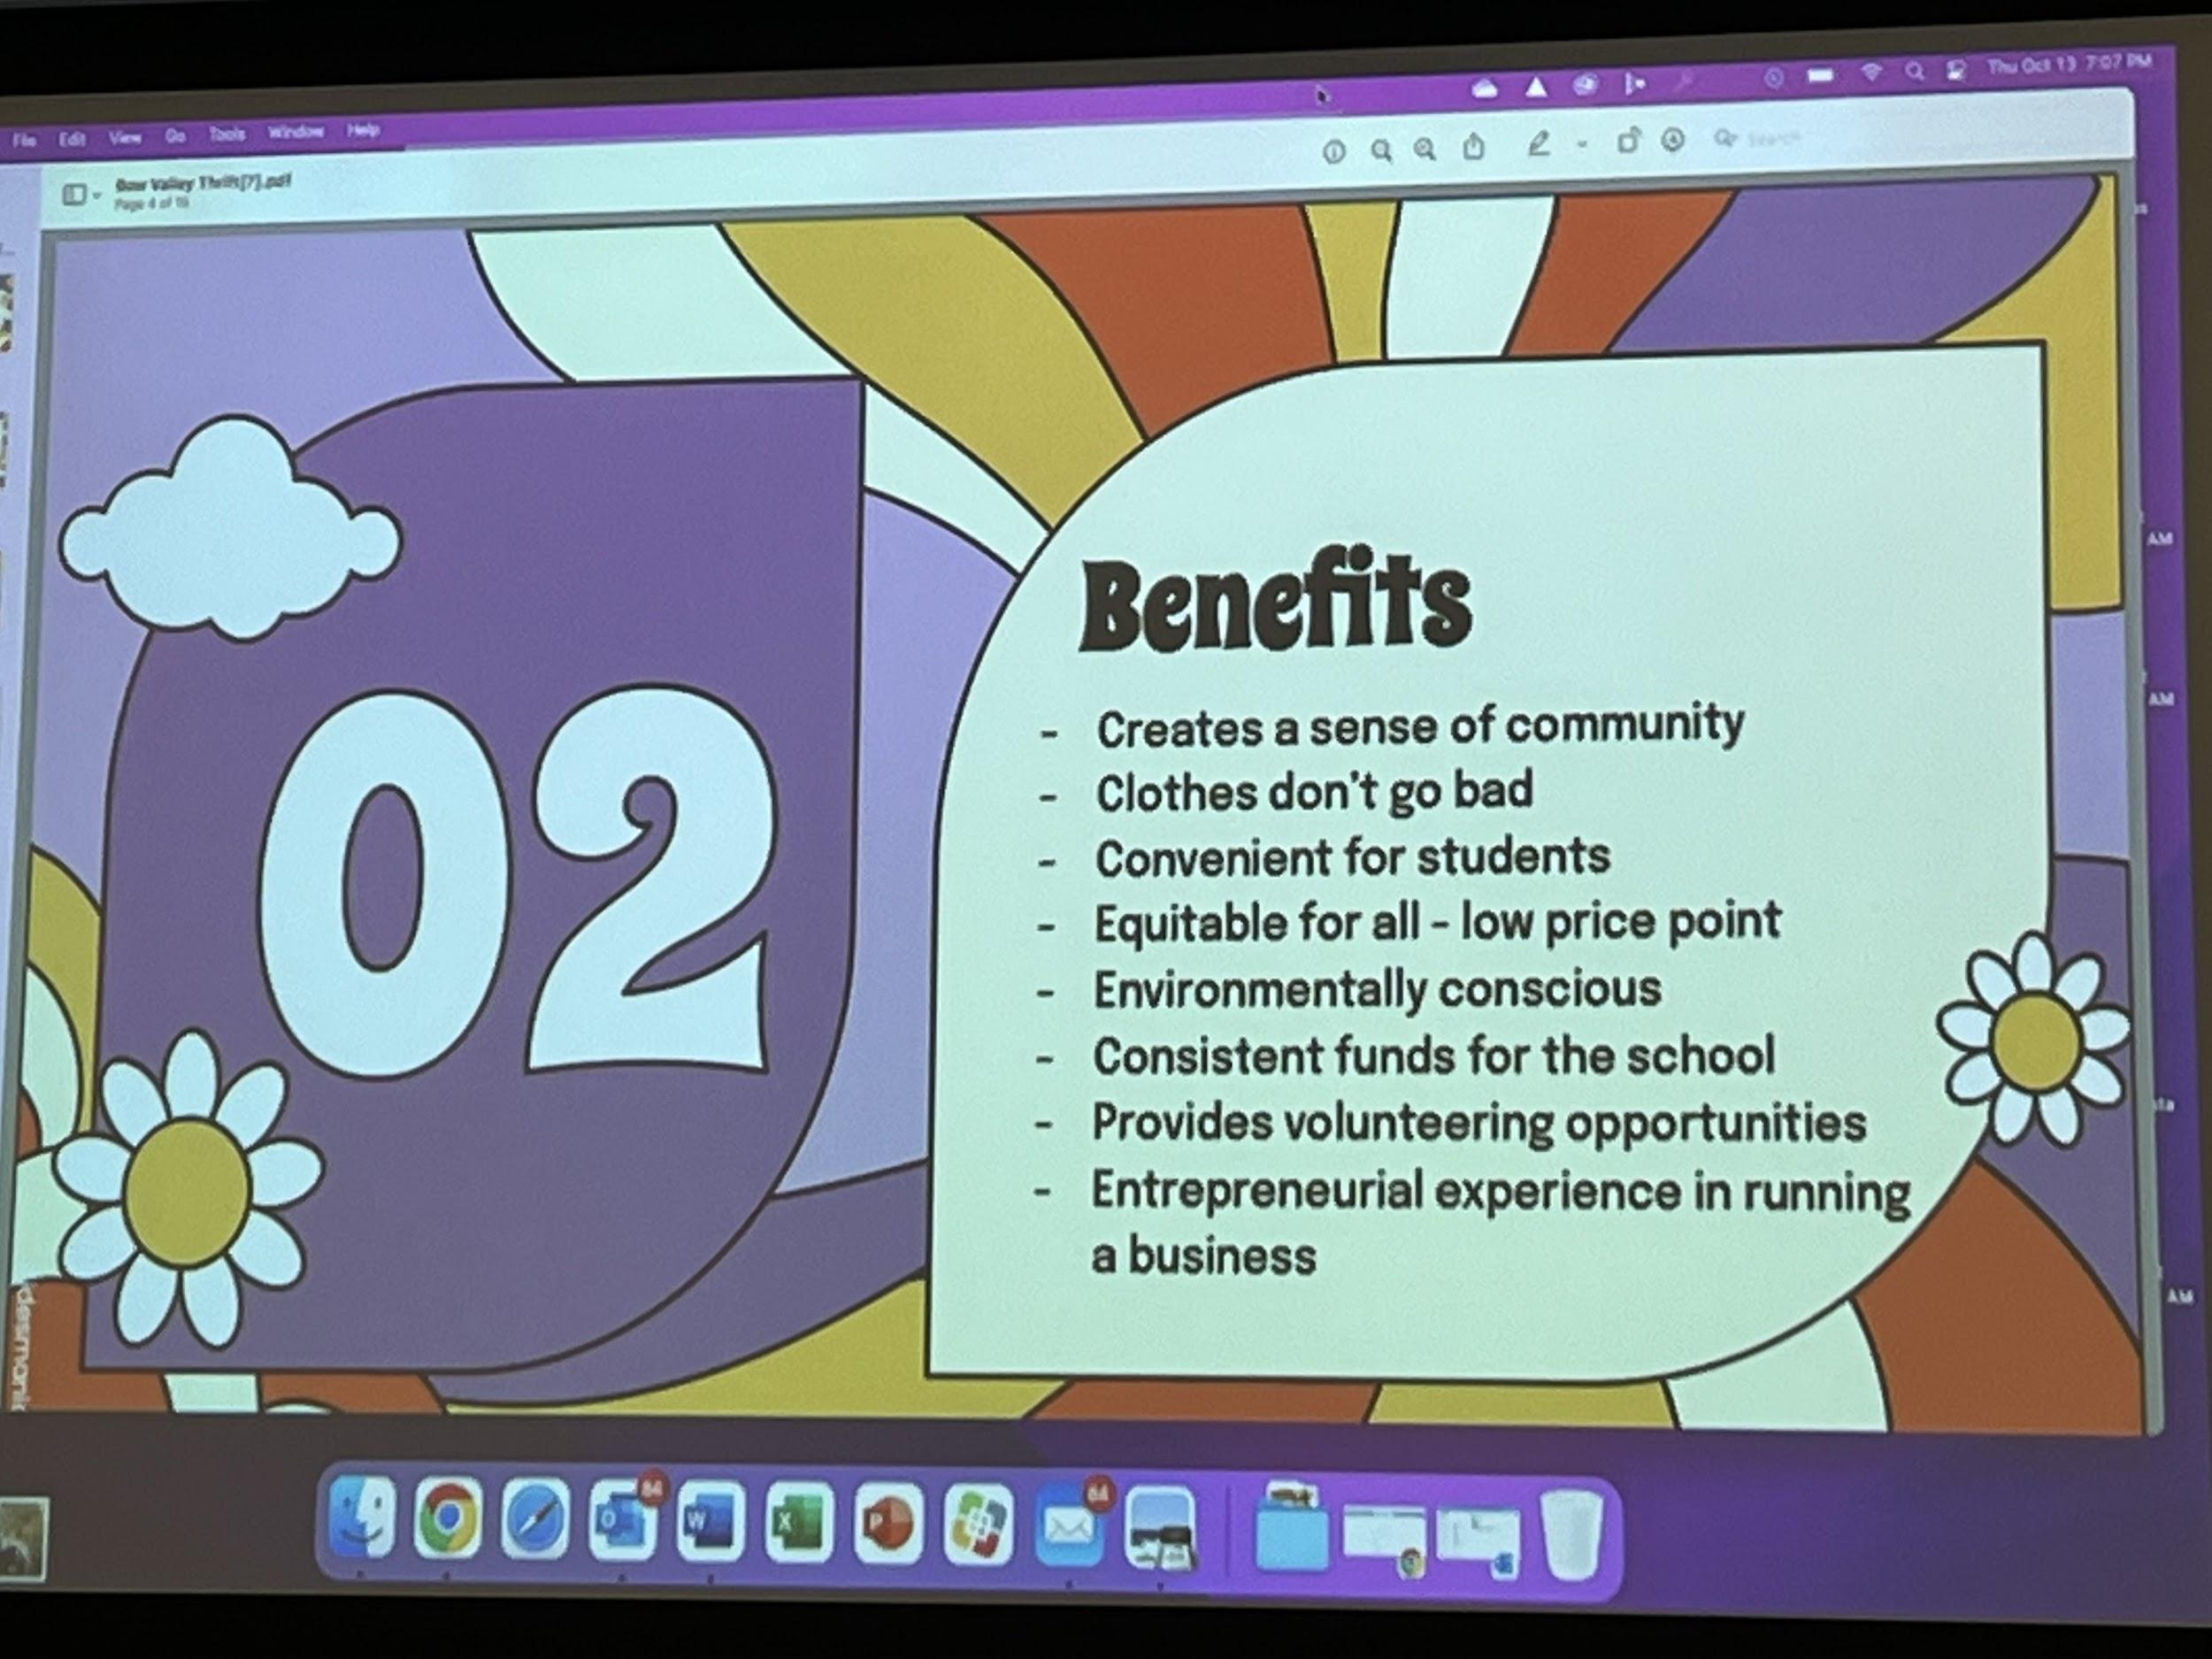

"Rocky View Schools acknowledges and recognizes all the Indigenous Peoples whose footprints have marked these lands from time immemorial. Together, we can learn and honor the ways of knowing of Indigenous Peoples, and all peoples, for future generations” read by Tracy Brooker - CHAIR
3. Approval of Agenda - Approved by Kari Rose, 2ed by Tracy Bruins
4. Approval of Minutes from Sep 15, 2022
Approved by Kari Rose, 2ed by Susan Brauss
5. Business arising from minutes
A) The “I Got Mind” 45-min presentation to take place immediately following today’s meeting - 7:30 PM
B) Operating Procedures and Bylaws - Approved updates and amendments. Code of Ethics will be used throughout the document.
C) Parent Survey Results- 306 reponses
6. Administration Update
- Workbook - data
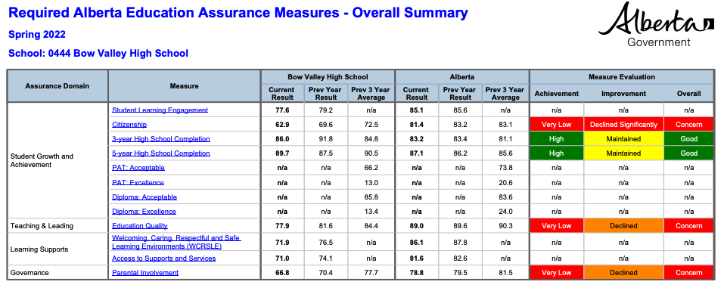
- Beliefs: Bow Valley High School connects authentically, responsively, entirely, and supportively. #BVCARES (

- What does this mean to you?
- Does this still represent BVHS?
- What does this look like for students?
- Parent Communication
7. Report from Board of Trustees – Fiona Gilbert- review the strategic plan before Monday October 17, 2022
8. Bobcat Backers Fundraising Update
-MASCOT ORDERED , due to supply and demand , we are expecting it will be ready for spring 2023. Design contest is running until October 11- October 21 for students to share their vision. WINNER will be announced on October 28. Prize is a 25.00 gift card to the Movie House. Stay tuned for a NAME the mascot contest in the new year. Stay tuned for details in Bobcat Trackers and BV Facebook Page.
- Dielmans fundraiser on until November 10, 2022,Stay tuned for details in Bobcat Trackers and BV Facebook Page.
- BOBCAT BACKERS next meeting is november 3, 2022 at 7pm.
9. New Business - Guest Speaker Series - TAB looking into bringing in more guest speakers, maybe in the months that the council isn’t meeting.
School Health and Wellness
For ideas and resources to support school wellness, visit our website at schools.healthiertogether.ca.
Alberta Health Services does not provide personal medical advice through email. AHS School Health & Wellness Promotion Team

10. Next Meeting: Thursday, December 8, 2022, 7 PM
Adjourned at 7:33pm
11. Adjournment - Please stay to participate in “I Got Mind” Guest Presentation by Bob Wilkies
albertafamiliywellness.org - 20 hour certification course

